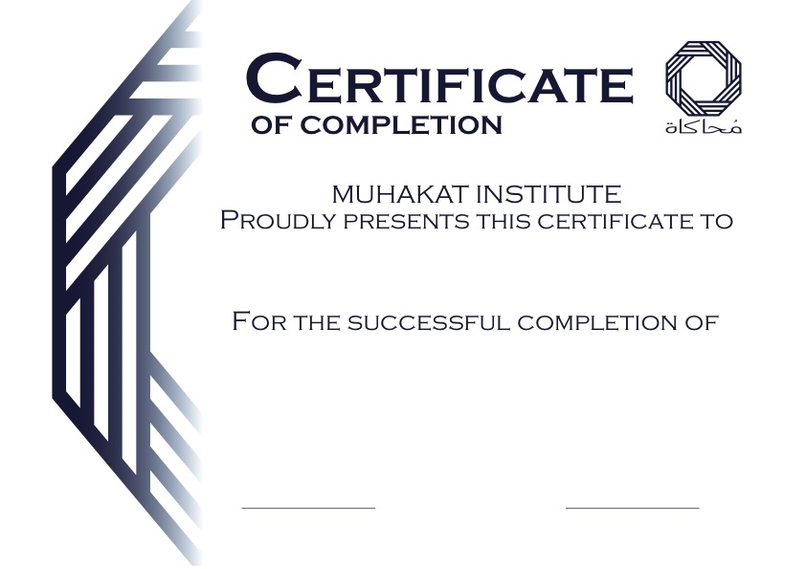

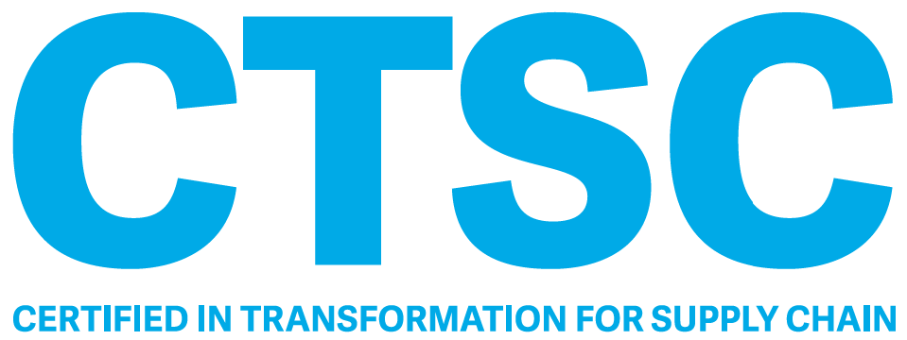

APICS CTSC Learning Proposal

March 2024 – DUBAI-UAE

Introduction

MUHAKAT is pleased to provide its training services proposal for ASCM-APICS CTSC training course in Dubai.

Welcome to Dubai!



***A vibrant city of a record-breaking attractions & experiences like no other... Dubai is the place to be in 2024.***

***It's no wonder it’s the first city to be named TripAdvisor’s #1 Top Destination in the World for three years running!***

How does MUHAKAT differentiate itself?

Muhakat Instructors has won the APICS Award of Excellence for their massive contribution to the supply chain discipline and education in the Middle East.



What makes us Special?

Muhakat Partners

APICS – ASCM Training and Certification Program

As an International Elite Premier Channel Partner for APICS - ASCM, the leading association for Supply Chain & Operations Management, MUHAKAT Consulting educates and supports the professionals in the Middle East who work in the fields related to advanced supply chain management and operations management to achieve and maintain their world-class levels of knowledge.

The Association for Supply Chain Management (ASCM) is the global leader in supply chain organizational transformation, innovation, and leadership. As the largest non-profit association for supply chain, ASCM is an unbiased partner, connecting companies around the world to the newest thought leadership on all aspects of supply chain. ASCM is built on a foundation of APICS certification and training spanning 60 years. Now, ASCM is driving innovation in the industry with new products, services and partnerships that enable companies to further optimize their supply chains, secure their competitive advantage and positively influence their bottom lines.

APICS is recognized globally as a standard of professional excellence and quality within the manufacturing and service industries. Founded in 1957, APICS (The Association for Operations Management), is a not-for-profit international organization. APICS offers certification, training and education programs and has a worldwide network of industry professionals. Its aim is to increase workplace performance. Of knowledge, MUHAKAT also helps enterprises to achieve business goals by improving and enhancing their management levels.

APICS Programs

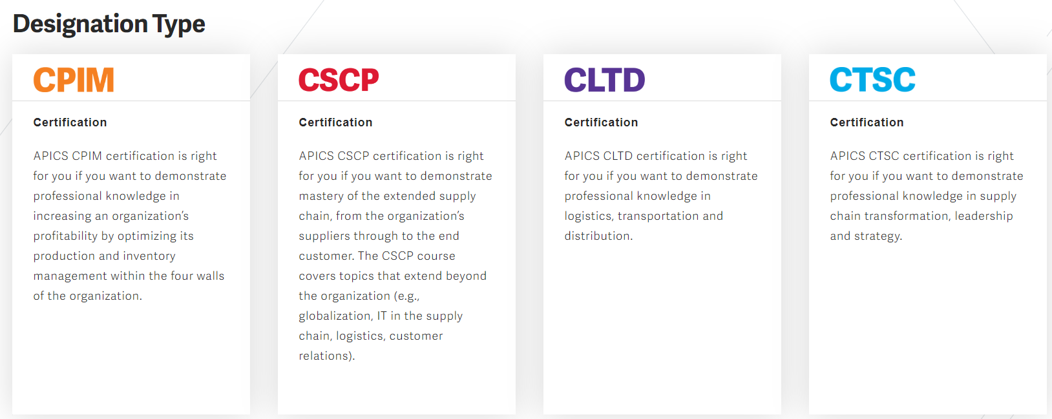

About APICS CTSC Program

CTSC focuses on best practices, knowledge, skills, and abilities to initiate and enact supply chain transformation. The program leverages components of globally recognized industry standards, including the ASCM SCOR Digital Standard (DS), Enterprise Standards for Sustainability, and the Digital Capabilities Model (DCM), as tools for assisting with supply chain transformation. The APICS CTSC candidate demonstrates in-depth knowledge of supply chain strategy and planning, order and warehouse management, transportation fundamentals and global logistics, including risk management and sustainability logistics.

Who is the APICS CTSC program designed for?

* Supporting or executing a supply chain transformation within their organization
* developing a supply chain strategy
* Creating business requirements documents for large-scale systems implementation.
* Developing and managing performance control towers, business intelligence capabilities, and supporting advanced analytics
* Supporting a supply chain network design (redesign)
* Defining and prioritizing digital capabilities or in a supply chain enabling role

Responsibilities

* Analyzing the current state of your company’s processes and comparing company performance to corporate goals
* Evaluate supply chain performance.
* Oversee supply chain improvement program or portfolio of projects.
* Team member on a supply chain improvement project

Outcomes

After earning your CTSC, you will be able to:

* Develop and deploy supply chain transformation initiatives.
* Identify risks and opportunities, and select the appropriate frameworks, models, and approaches to effect transformation.
* Apply systems thinking to develop, analyze and validate concept alternatives for transformation.
* Manage skills, roles, responsibilities and infrastructure needed for successful supply chain transformation.
* Identify tools and technologies to enable effective supply chain transformation.
* Identify and implement strategies for reinforcing and replicating improvements.
* Use your new knowledge and skills to complete key implementation program deliverables.
* Improve overall operations performance.

Candidate Benefits

The CTSC program provides candidates with the strategic knowledge and skills needed to assess, evolve, adapt, and transform their organization’s supply chain from start to finish.

Company Benefits

The CTSC program equips employees with the strategic knowledge required to identify and manage risks, apply systems thinking to develop and validate concept alternatives for transformation, and develop, deploy, and manage change for a successful supply chain transformation.

Supply Chain operations areas most suited for designation

* Supply chain design
* Procurement
* Supply chain management
* Project and/or portfolio management
* Planning

Contents of The CTSC Training Program

The CTSC Learning System and preparation courses are broken down into 4 modules.

**Module 1: Supply Chain Transformation Overview**

**Module 2: Preparing for Supply Chain Transformation**

**Module 3: Executing Supply Chain Transformation**

**Module 4: Review of Supply Chain Transformation**

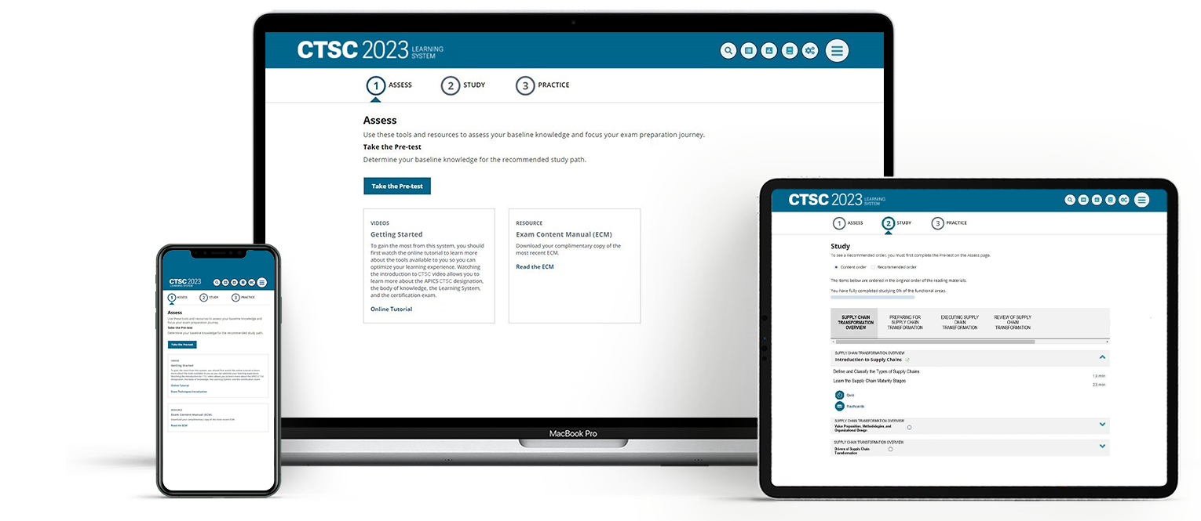

|  |  |
| --- | --- |
| CTSC Module Contents | |
| Module 1: Supply Chain Transformation Overview  Section A: Supply Chain transformation   * Topic 1: Define and classify the types of Supply Chains * Topic 2: Understand the Supply Chain Maturity Stages * Topic 3: Understand Organizational and Business Units strategies. * Topic 4: Understand Supply Chain strategies. * Topic 5: Explore Business Cases for Transformation and a Transformation Road Map * Topic 6: Supply Chain Transformation Leadership and Culture   Section B: Value Proposition, Methodologies and Organizational Design   * Topic 1: Understand Value Proposition and Value Chains * Topic 2: Research Models, Frameworks, and Benchmarking Tools * Topic 3: Explore Cost and Service Optimization Road Maps * Topic 4: Understand Business Context   Section C: Drivers of Supply Chain Transformation   * Topic 1: Customers, Culture, and Capability Drivers of Supply Chian Segmentation * Topic 2: Business Benchmarking and Business Value   Module 2: Preparing for Supply Chain Transformation  Section A: Select Supply Chain Transformation Drivers   * Topic 1: Create Portfolio Charter and Select Supply Chain Transformation Tools * Topic 2: Supply Chain Transformation Drivers * Topic 3: Strategic Imperatives * Topic 4: Digitalization and Data Management Technology * Topic 5: Product and Service Technologies * Topic 6: Maturity Assessment * Topic 7: Identify Common Misalignments | Section B: Assess Supply Chain Current State   * Topic 1: Define to-be Metrics and Use Them to Analyse As-Is Performance * Topic 2: Prioritize the Supply Chain to be Designed, Set Attribute Targets, Map, and Benchmark * Topic 3: Create Detailed As-ls Maps, Models, and Diagrams * Topic 4: Perform Gap Assessments   Section C: Conceptualize the Future-State Supply Chain Operating Model   * Topic 1: Prioritize Defects, Identify Projects, and Analyse Alternatives * Topic 2: Create To-Be Models, Simulations, and Capability Sets   Section D: Identify Initiatives to Address Gaps   * Topic 1: Identify and Scope Transformation Initiatives * Topic 2: Sequence and Prioritize Initiatives   Section E: Initiate Transformation Work Streams and Projects   * Topic 1: Create Project Charters and Hold a Transformation Program Kickoff * Topic 2: Develop Resource Management Plan * Topic 3: Document Stakeholder and Communication Management Plans * Topic 4: Document Change Management Plan(s)   Section F: Develop and Iterate Preliminary Transformation Business Cases   * Topic 1: Use a Business Case Development Process and Set Targeted Value Drivers * Topic 2: Quantify Financial Value of Supply Chain Improvements * Topic 3: Determine Resources Needed and Estimate Cost and Schedule * Topic 4: Select Transformation Program KPls * Topic 5: Craft Messaging Content   Section G: Perform Post-Approval Tasks   * Topic 1: Assemble Project Portfolio * Topic 2: Validate Costs, Schedules, Resources, and KPIs * Topic 3: Refine Supply Chain Transformation Business Case * Topic 4: Establish and Align Portfolio Governance and Draft Execution Plans |

|  |  |
| --- | --- |
| CTSC Module Contents -Continue | |
| Module 3: Executing Supply Chain Transformation  Section A: Adopt a Change Management Plan   * Topic 1: Select and Tailor Change Management Method * Topic 2: Assign Change Management Roles and Responsibilities * Topic 3: Provide Planned Communications and Training * Topic 4: Identify and Implement Incentives   Section B: Design and Implement Supply Chain Transformation Work Streams and Projects   * Topic 1: Collaborate with Internal and External Stakeholders * Topic 2: Design and Test Solutions * Topic 3: Implement Project Policies and Individual Projects * Topic 4: Scale Up to Enterprisewide Solutions   Section C: Implement Governance and a Risk Management Framework   * Topic 1: Set Portfolio and Project Management Governance * Topic 2: Establish Secure, Resilient, and/or Sustainable Supply Chains   Module 4: Review of Supply Chain Transformation  Section A: Assess the Transformation   * Topic 1: Review and Provide Feedback on Project Portfolio Performance * Topic 2: Reassess Supply Chain Transformation Maturity   Section B: Communicate Results and Reflect on the Transformation   * Topic 1: Measure, Document, and Report Results * Topic 2: Implement Continual Improvement and Identify Future Initiatives |  |

Benefits of an Instructor-Led Course

* Learn from an experienced instructor who provides expertise, insights, and one-on-one guidance.
* Network, share experiences, and discuss topics with a diverse group of professionals.
* Stay on track to earn your certification with a structured learning experience.

In addition to the guidance, you will receive in the classroom, you will also receive the APICS CTSC Learning System which provides the most comprehensive, effective, and up-to-date exam preparation tools available. The online platform includes learning activities, a personalized study experience, practice exam questions and convenient access to reading materials.

How Will I Study?

The CTSC Learning System incorporates three components to help you apply the concepts and test your understanding and retention of the information.

1. ASSESS

* Complete the Pretest to determine your current knowledge and identify areas for improvement.
* Create a SmartStudy plan using your pretest results to identify your most challenging topics and estimate study time.

2. STUDY

* Access the digital version of the reading materials for access to the printed content on the go.
* Take the Chapter Quizzes to test knowledge retention and receive immediate feedback, answer rationales, and references to the relevant sections in the reading materials.
* Complete the Learning Activities using real-life scenarios in a new case study format to help reinforce concepts presented.
* Study Flashcards to reinforce your memory of key terms, concepts, and definitions.

3. PRACTICE

* Take the Practice Exam which was designed to help users gain experience with the format of the computer based CTSC exam.
* Access additional information about the certification exam, study tools, and test-taking tips.
* Review Reports that include pretest scores and chapter-specific quiz scores to track progress and learning gain.

CTSC Exam Details:

|  |  |  |
| --- | --- | --- |
| Exam type | |  | | --- | | **Computer-based multiple choice.** | |
| Exams | Must pass one exam to become certified.  150 questions. 130 operational and 20 pretest* questions. |
| Exam Length | 3.5 hours |
| Exam Content | Exam content is developed according to the test outline included in the CTSC Exam Content Manual and validated by global subject matter experts. Exam questions are monitored through rigorous psychometric calibration and cross-referenced to industry-approved source material. |
| Exam Location | exam is delivered on-demand via computer-based testing (CBT) at Pearson VUE test centers, which are located around the world. |
| Exam Scoring | APICS uses a scaled score methodology, which is a technique for equating scores in which the degree of difficulty varies from one exam form to the next.  The APICS CTSC score range is 200 to 350.  Fail = 200–299  Pass = 300-350 |

*Pretest questions do not contribute to the total score but are necessary for research purposes. The pre-test questions are randomly distributed among the scored items and are used for statistical purposes only. Candidates should answer all exam questions.

Your Expert Facilitators

|  |  |
| --- | --- |
|  | **SAMER MAJDI ALMADHOUN**    **MBA, CSCP, CLTD, CPIM, SCOR-P**  **APICS Recognized Master Instructor**  Co-author of the CTSC Courseware, Supply Chain advocate that enjoys 30 years of experience in various business sectors with emphasise on supply chain transformation as a core of experience.  Familiar with the latest technological and business trends associated with the fields of interest, lead several business transformations in the Middle East and delivered +5000 Training hours in various Supply Chain topics.  Samer also Co-Authored the SCOR DS latest version, the APICS Supply Chain Dictionary & the APICS Train The Trainer courseware. |

Financial Offer

|  |  |
| --- | --- |
| Early Bird Registration  (Register before 25/02/2024) | Regular Registration |
| $3810 | $4000 |
| * Class attendance: 40 Hours (5 days including lunch and coffee breaks) * Learning System: Digital learning system, Online study tools with quizzes, practice exam, learning activities and resource center (for one year from date of purchase) * Exam * Exam retake * One-year ASCM Plus Membership * Free instructor and technical support | * Class attendance: 40 Hours (5 days including lunch and coffee breaks) * Learning System: Digital learning system, Online study tools with quizzes, practice exam, learning activities and resource center (for one year from date of purchase) * Exam * Exam retake * One-year ASCM Plus Membership * Free instructor and technical support |

*\*Prices are subject to change from ASCM without prior approval*

*\*\*\* Full Attendance is required to obtain APICS Certificate of Completion, exceptions may apply.*

Payment Terms and Conditions:

**Validity**

1. Muhakat Institute holds the right to cancel or postpone the course according to the number of attendees.

**Payment Terms**

The payment terms below are applied to all options above:

* 1. 100% of the full amount on advance upon receiving the invoice.
  2. The payment method is by Money Transfer or Online Payment.

**TERMS & CONDITIONS**

**1.** **Cancellation Policy**

i. All cancellations must be done in writing

ii. No refund for cancellations.

**2.** **Force Majeure:**

If the event is postponed, canceled or abandoned by reason of war, fire, storm, explosion, national emergency, labor dispute, strike, lock-out, civil, disturbance, actual or threatened violence by any terrorist group, or any other cause not within the control of our organization, we shall be under no liability to ‘Company’ for non-performance or delay in performance of obligations under this contract or otherwise in respect of any actions, claims,

losses (including consequential losses) costs or expenses whatsoever which may be brought against or suffered or incurred by ‘Company’, as the result of the happening of any such events.

Agenda

|  |  |  |  |  |  |  |
| --- | --- | --- | --- | --- | --- | --- |
| March 2024 | | | | | | |
| **Sat** | **Sun** | **Mon** | **Tue** | Wed | Thu | **Fri** |
|  |  |  |  |  |  | **1** |
| **2** | **3** | **4** | **5** | 6 | 7 | 8 |
| 9 | 10 | 11 | 12 | 13 | 14 | 15 |
| 16 | 17 | 18 | 19 | 20 | 21 | 22 |
| 23 | 24 | 25 | 26 | 27 | 28 | 29 |
| 30 | 31 |  |  |  |  |  |

